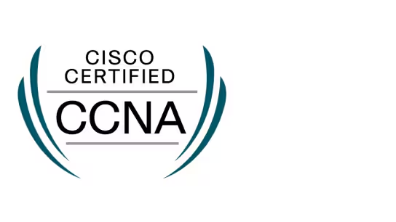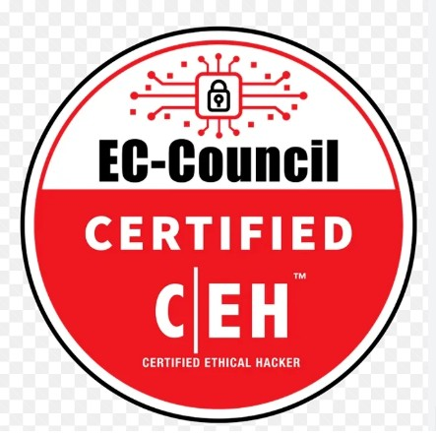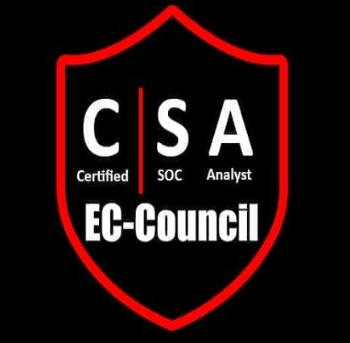
Mohammad Sharif Bakhtyari Sterling, VA 20165 | +1 (971) 900-3335 | sharif.bakhtyari@gmail.com | https://www.linkedin.com/in/m-sharif-bakhtyari/
Network & Systems Operations Engineer | Data Center & Enterprise Infrastructure

Professional Summary
- Network & Systems Operations Engineer with 10+ years supporting enterprise and hyperscale data center environments.
- Extensive hands‑on experience performing rack and stack deployments for servers, switches and enterprise infrastructure.
- Strong background supporting production environments while coordinating with NOC teams and remote engineers.
- Experienced validating Layer 1–Layer 3 connectivity across enterprise network infrastructure.
- CCNA certified with strong operational networking knowledge and troubleshooting capability.
- Expertise in structured cabling including fiber and copper installation, labeling and validation.
- Hands‑on experience supporting Linux cluster environments within large data centers.
- Operational support experience with Windows Server environments including Active Directory, DNS and DHCP.
- Skilled with ServiceNow ITSM workflows including incident, change and operational ticket documentation.
- Experienced performing rack‑level diagnostics and assisting engineering teams during outages.
- Strong understanding of enterprise operational procedures and change management processes.
- Proven ability to maintain infrastructure documentation including rack diagrams and connectivity maps.
- Experienced collaborating with infrastructure teams to maintain uptime and operational stability.
- Reliable operations professional with strong attention to procedure, safety and documentation.

Core Skills
- Data Center Operations – rack & stack, IMAC, staging, deployment, decommissioning
- Structured Cabling – fiber and copper installations and testing
- Network Operations – Layer 1–3 troubleshooting and connectivity validation
- Hardware Installation – servers, switches, routers
- Incident Response and outage troubleshooting
- NOC coordination and escalation support
- Linux server cluster operational support
- Windows Server operations including Active Directory
- ServiceNow ITSM ticket workflow management
- Enterprise infrastructure support in production environments

Professional Experience

Network & Systems Operations Engineer – Onsite Enterprise Support | Multiple Enterprise Clients | Jul 2024 – Present
- Provide onsite operational support across enterprise production environments.
- Install and mount network switches, routers and servers according to rack elevation diagrams.
- Perform rack and stack activities including equipment mounting, power connections and cable routing.
- Run and terminate fiber and copper cables ensuring proper labeling and cable management.
- Validate physical connectivity between network infrastructure devices.
- Assist NOC and engineering teams during incident troubleshooting.
- Perform rack level diagnostics to identify physical infrastructure issues.
- Conduct post‑maintenance validation checks after infrastructure changes.
- Update ServiceNow tickets with operational updates and validation results.
- Maintain rack layout documentation and cable mapping records.
- Support hardware replacement including NICs, drives and memory modules.
- Assist with server staging and infrastructure readiness tasks.
- Ensure compliance with operational and safety procedures.

Data Center Technician – Meta | Hillsboro, OR | Nov 2023 – Apr 2024
- Supported daily operations within hyperscale Meta data center facilities.
- Installed servers and network devices following rack diagrams and deployment instructions.
- Performed hardware replacement including hard drives, NICs and memory modules.
- Maintained cable management standards across fiber and copper infrastructure.
- Validated system health after hardware installation or replacement.
- Participated in server staging and infrastructure deployment preparation.
- Supported hardware decommissioning and asset removal procedures.
- Updated inventory systems and operational documentation.
- Collaborated with engineering teams during infrastructure maintenance windows.
- Assisted with troubleshooting hardware related issues impacting production systems.
- Maintained operational documentation related to rack layouts and connectivity.
- Ensured adherence to Meta operational procedures and safety policies.

Data Center Cluster Support Specialist | Hillsboro, OR | Mar 2022 – Nov 2023
- Supported Linux server clusters operating inside Intel enterprise data centers.
- Performed node replacements and hardware diagnostics across cluster environments.
- Maintained connectivity between cluster nodes and network infrastructure.
- Supported firmware updates and system validation procedures.
- Assisted with network troubleshooting impacting cluster operations.
- Maintained rack level cabling infrastructure across cluster racks.
- Documented infrastructure changes and operational updates.
- Participated in incident troubleshooting and outage support.
- Collaborated with infrastructure engineers to maintain cluster uptime.
- Performed system validation after maintenance activities.
- Maintained operational documentation and hardware tracking records.
- Assisted with lifecycle management of cluster infrastructure.

Network Operations Engineer – US Embassy Project (ANIM) | Kabul, Afghanistan | Jul 2012 – Aug 2020
- Supported enterprise LAN and WAN infrastructure within mission critical government environments.
- Worked with senior engineers during network deployment and upgrade projects.
- Assisted with VLAN segmentation tasks supporting network architecture.
- Participated in troubleshooting network outages impacting enterprise services.
- Maintained network diagrams and operational documentation.
- Supported Windows Server environments including Active Directory.
- Maintained DNS and DHCP services across enterprise infrastructure.
- Installed network hardware including switches and routers.
- Provided operational monitoring support for enterprise networks.
- Maintained change management documentation and network records.
- Performed connectivity validation after network infrastructure changes.
- Supported enterprise infrastructure maintenance activities.

System Administrator – Contrack International Inc Project (YLBEC) | Kabul, Afghanistan | Oct 2011 – Jul 2012
- Installed and configured Windows Server 2008 infrastructure.
- Managed Active Directory users, permissions and authentication policies.
- Maintained DNS and DHCP services across enterprise network environments.
- Performed system patching and server maintenance tasks.
- Provided Tier 1 and Tier 2 support for infrastructure related issues.
- Maintained operational documentation and configuration records.
- Supported server monitoring and system health validation.
- Assisted with deployment of enterprise server infrastructure.
- Performed troubleshooting across system and network environments.
- Ensured operational stability of server infrastructure.

Education
Master of Computer Engineering – Payam‑e‑Noor University, Kabul, Afghanistan (WES U.S. Equivalency)
Bachelor of Computer Science – Dunya University, Kabul, Afghanistan

Certifications
Cisco Certified Network Associate (CCNA)
Certified Ethical Hacker (CEH)
Certified SOC Analyst (CSA)
Microsoft Certified IT Professional (MCITP)

